Covid-19 impact on youth

students

By

Kolte Shreeganesh Manik.

(S.Y.BCA(Science).

Table of Contents

**Executive summary**……………………………………………………………………………………..

Background and purpose……………………………………………………………………………

Results and analysis…………………………………………………………………………………..

Conclusion and Recommendations…………………………………………………………....

**What is this report about?** .............................................................................

**Why is this report needed?** ............................................................................

1. **INTRODUCTION**………………………………………………………………………………….
2. **METHODOLOGY**…………………………………………………………………………………
3. **FINDINGS**…………………………………………………………………………………………..

Age, geographical and gender distribution………………………………………..

Youth and covid-19 information………………………………………………………..

Attitudes of young students towards covid-19………………………………….

1. **DISCUSION**………………………………………………………………………………………..

How have the different genders among student youth answered the

Survey? ................................................................................................

How have youth students VS non-youth students answered the

Survey? ……………………………………………………………………………………………

Qualitative suggestions to WHO………………………………………………………

Recommendations……………………………………………………………………………

1. **Final considerations**………………………………………………………………………….

Executive Summary

**BACKGROUND & PURPOSE**

As of end-September 2020, over 32 million people were reported to have been infected by Coronavirus (also known as COVID-19) and nearly 1 million people have lost their lives from the disease[1](World Health Organization, 2020). The COVID-19 pandemic has drastically impacted the state of the global economy, people’s livelihoods and health. Although COVID-19 has mostly affected the elder generation’s health, it has also disproportionately affected youth (aged 21 and below) and their access to education and work opportunities.

The health crisis and lockdowns in effect across the globe fuelled the spread of misinformation pertaining to COVID-19 and consequently, made it difficult for health authorities to deliver credible, accurate information for populations to take the necessary steps to protect their families. Moreover, the spread of misinformation in this era of social media has also resulted in a peak in the number of reported mental health cases all around the world.

The purpose of this study was to investigate the impact of this ongoing health crisis and the spread of misinformation on youth; and their attitude or outlook to their future prospects. Our objectives were to: Identify the sources and platforms from which youth relied on pertaining to public health

Investigate the level of trust that youth had in

**public** health guidance from National Health

Authorities and from WHO Investigate the health impact of the COVID-19 pandemic on youth

Understand youth perceptions of the impact on their future due to the COVID-19 pandemic

**RESULTS AND ANALYSIS:**

A short, anonymous and youth-targeted questionnaire was developed via Google Forms and translated from English to 7 other UN languages (French, Arabic, Russian, Mandarin, Hindi, Portuguese and Spanish). The survey was disseminated via mail listings, digital social networks and other media and informational channels through established networks of the youth organizations behind this study. The survey received 3,122 respondents in the 2-week+ period it was sent out. Of those 3,122, 2,666 (85%) respondents were youth aged 21 and below from 1 21 countries across 6 WHO regions. Asia (45%) and the LATAM (24%) had the highest number of respondents respectively. 991 identified themselves as Male (37%), 1,650 identified themselves as Female (62%) whilst the remaining 1% either classified themselves as Other or preferred not to mention their gender.

In our analysis, we looked first at how all youth responded to the survey, following which we comparatively analysed their responses based on their socio-economic background, region, gender and age clusters (youth vs non-youth). We also analysed how COVID-19 had impacted the Sustainable Development Goals from a youth perspective. Majority of youth stated that they know how to critically assess the trustworthiness of COVID-19 related information (85%) and that they always checked if the information they received was verified to a satisfactory level before sharing it online (82%). Although youth have not been highly affected from a physical health perspective due to COVID-19, majority have been negatively affected from a mental health perspective (58%). Furthermore, youth feel that COVID-19 has negatively affected their future in terms of education, employment and mental health. Finally, youth from low- and middleincome countries felt more that their future education opportunities and future financial stability have been negatively or strongly negatively affected due to COVID-19 as opposed to youth from high income countries.

**CONCLUSION & RECOMMENDATIONS**

Whilst the findings of this report were by no means representative of the perceptions of the billions of youth that live around the world, it was indicative of youth’s perceptions and attitudes towards COVID-19. From the survey, several qualitative suggestions to WHO were shared. These included: Increasing locally-tailored actions and approaches based on specific country and cultural, religious and social contexts, local languages in communication and engagement of local and national authorities and decision-makers, especially in low and middleincome countries (LMIC) and those in low-resource settings. Emphasis also came towards awareness and education of people focusing on those not reachable by technology tools such as in rural areas, the elderly, and poor ones. Other stakeholders include health workers, media, decision-makers and influencers

Suggestions about increasing the “honesty and transparency” of messaging by WHO and to ensure that guidance is backed up with data and references. From these recommendations, we also deduced that the clear call to action from youth was for governments, international organisations and NGOs to take the necessary steps to reduce the burden of COVID-19 on mental health and ensure support and access to education and employment opportunities for everyone.

What is this report about?

*“For young people, and especially for vulnerable youth, the COVID-19 crisis poses considerable risks in the fields of education, employment, mental health and disposable income. Moreover, while youth and future generations will shoulder much of the long-term economic and social consequences of the crisis, their well-being may be superseded by short-term economic and equity considerations*[2]*.”* (OECD, 2020)

The COVID-19 pandemic has, in a few months, changed and shaped the world by affecting people’s lives in an unprecedented manner. The impact of COVID-19 is cross-generational and has affected everyone in different ways. Although the health and socio-economic crisis generated by this pandemic has mostly affected elder populations and those with pre-existing health conditions, the effect of COVID-19 on youth should not be neglected.

Against this background, this report aims to describe the attitudes, knowledge and awareness of youth, aged 21 and below towards COVID-19. The information for this report was captured in the “COVID, Youth and information Survey”, a questionnaire developed by the Global Shapers community, the International Federation of Medical Students’ Associations (IFMSA), the

#MoreViralThanTheVirus movement, the Health and

Information Literacy Access Alliance (HILA Alliance

- GAPMIL/UNESCO) with technical support from the World Health Organization (WHO) and UNESCO. The survey received 3,122 responses from 140 countries, of which 2,666 responses from 1 21 countries were that of youth (aged 21 and below).

The findings from the above survey are outlined in this report. It analyses the sources and channels that young people have used and relied on to inform themselves about the pandemic. The report addresses and analyses one of the most relevant issues related to the crisis: misinformation and source reliability. The report further illustrates how COVID-19 has affected the lives of youth such as their physical and mental well-being and perceptions and feelings towards the future.

# Why is this report needed?

Youth represent close to 20% of the total world population (UNDESA, 2019)[3]. Their voices, perceptions and actions have, therefore, the power to shape society’s present and future in a substantial and impactful way. This is especially true, when it comes to the response to COVID-19. The contribution of young people to deliver impactful projects addressing issues arisen by COVID-19 during this crisis has been enormous (see responses to the COVID-19 pandemic from a few youth organizations such as the Global Shapers Community [here](https://www.globalshapers.org/impact/themes/covid-19), IFMSA [here](https://ifmsa.org/covid19/), #MoreViralThanTheVirus [here](https://mvttv.co/) and the HILA alliance [here](https://en.unesco.org/themes/media-and-information-literacy/gapmil/covid19)).

As youth action can make a difference for today and the future, it is of the utmost importance that the response to COVID-19 addresses their needs and takes their voices into consideration. Under the current circumstances it is crucial to avoid shortterm policies and ensure that all human rights, even beyond health care, are guaranteed and respected. Policies should meet and address young people’s needs in order to enable them to support their communities, fight dis-information and fight the pandemic through socially relevant and innovative projects.

In trying to assess the perceptions of youth, the survey and this report have been developed by youth with the intention of giving youth a voice. This report aims, therefore, to be a step forward in the guarantee of the needs of youth and to give youth the opportunity to provide suggestions to international and national health organizations on how they may improve their guidance and communications pertaining to COVID-19.

# 1. Introduction

The COVID-19 pandemic has created long-lasting effects on youth from an education and employment perspective.

Since its first case was initially reported back in December 2019, COVID-19 has silently and rapidly spread across the globe. It is evident that the indirect impacts from COVID-19 will have long lasting adverse effects to the general public even after the pandemic is over.

Whilst youth are not considered to be within the risk groups for COVID-19 as compared to those in older age groups or those with pre-existing health conditions, the indirect impacts from the COVID-19 pandemic on youth has been profound. Youth, as defined by some countries, are persons between the ages of 15 and 21 years of age. Consequently, this is the period when a person transitions from education into the labour market.

Prior to the pandemic, this transition had become significantly more difficult in recent decades, with high unemployment figures across the board due to economic recessions and labour market saturation. This situation has now been worsened with the introduction of lockdowns and companies being forced to trim their workforces and freeze their hiring These are the effects of the COVID-19 infodemic, where the rapid spread of both accurate and inaccurate information aboutCOVID-19 has made it difficult for the general public to make informed decisions that would safeguard their loved ones and themselves.

The COVID-19 pandemic calls on all of us to work together to ensure our collective health, safety, and wellbeing. Being and representing youth ourselves, the authors and organizations behind this study, namely the Global Shapers community, the International Federation of Medical Students’ Associations (IFMSA), the #More Viral Than The Virus movement and the UNESCO affiliated HILA alliance, have put this together to investigate the current attitudes and perceptions of our demographic i.e. youth (aged 21 and below) towards COVID-19.

Our objectives were to: Identify the sources and platforms from which youth relied on pertaining to public health

Investigate the level of trust that youth had in

Public health guidance from National Health authorities and from WHO

Investigate the health impact of the COVID-19 pandemic on youth

Understand youth perceptions of the impact on their future due to the COVID-19 pandemic

The results from this report will be shared with the

2. Methodology

To achieve our objectives outlined in the Introduction, we engaged in the following activities: Developed a short, anonymous, youth focused survey (see Annex 1) built with Google Forms about how youth accessed and filtered information pertaining to COVID-19 whilst further understanding their perceptions on how COVID-19 has affected them individually from an economical , social and health perspective,

Translated the survey from English to seven

different languages, namely Arabic, French, Hindi, Mandarin, Portuguese, Russian and Spanish; Shared the survey through mail listings, digital social networks and other media and informational channels through established networks of the youth organizations behind this study,

Collected responses through our survey between July 13th 2020 and July 28th 2020; Translated, compiled and assessed data through Google Sheets via Google Form which was then exported to Python programming that was used for data cleaning, and,

Analysed findings and drew discussion points and final considerations that are outlined in this report.

3. Findings

**AGE, GEOGRAPHICAL AND GENDER DISTRIBUTION**

The survey received 2,666 respondents aged 21 years and below from 1 21 countries. Of these respondents, 37% were male whilst 62% were female.

|  |
| --- |
|  |

The survey received 3,122 respondents in total from all age demographics. Of the 3,122 respondents, 2,666 (85% of the total survey) were 21 years old and below and resided in 1 21 countries across 6 regions. This report will focus on the responses within this age group i.e. youth.

# The survey specifically asked respondents the country that they currently lived in instead of their nationality. This is because some, if not many, youth choose to live outside their motherland for education, employment and/or personal reasons. Thus, obtaining findings for youth based on their nationality may have skewed results on specific questions, such as perceptions about guidance

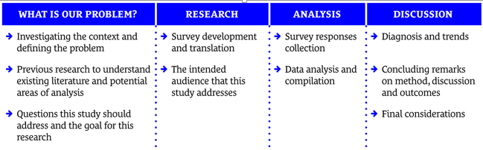

released by the National Health Authority, a specific question asked in the survey.

The different countries were divided into regions namely Asia, Latin America and the Caribbean, Europe, Africa, Northern America and the Caribbean as defined by the 2019 regional classifications of the Joint Malnutrition Estimates established by an interagency team comprising UNICEF, WHO and the World

Bank Group[4] (UNICEF-WHO-The World Bank Group, 2019).

The number of respondents and their relevant percentage to the total survey responses from these

different regions were as follows:

**REGION**

**RESPONDENTS**

**%**

h

Asia

h

1201

h

%

45

h

Latin America

and the Caribbean

h

627

h

24

%

h

Europe

h

329

h

12

%

h

Africa

h

272

h

10

%

h

Northern America

h

216

h

%

8

h

Oceania

h

21

h

1

%

As noted in the previous table, the survey received the most number of responses from Asia (45%) whilst the least number of responses were from Oceania (1%). Considering that the survey only received 21 responses from Oceania, their responses will be considered in the wider youth analysis within this section but will not compare Oceania against other regions in the next section (Discussion). Of the 2,666 respondents, 991 identified themselves as Male (37%), 1,650 identified themselves as Female (62%) whilst the remaining 1% either classified themselves as Other or preferred not to mention their gender.

**Whilst the findings of this report is by no means representative of the perceptions of the billions of youth that live around the world, it is indicative of youth’s perceptions and attitudes towards COVID-19.**

**YOUTH AND COVID-19 INFORMATION**

Majority of youth stated that they know how to critically assess the trustworthiness of COVID-19 related information and that they always checked if the information they received was verified to a satisfactory level before sharing it online.

The survey asked two questions pertaining to the media channels i.e. social media platforms, television news, WHO or National Health Authority (NHA) websites and social media accounts etc. that youth relied on for information pertaining to COVID-19 and sources that youth trusted for guidance pertaining to COVID-19 i.e. friends and family, celebrities and influencers, WHO, National government or health authority etc.

The top 5 most relied upon channels of media for information pertaining to COVID-19 for youth were WHO (48%), Newspapers/Electronic Journals (48%), Television News (42%), National Health Authorities (37%) and Facebook (24%). Moreover, youth around the world indicated that their most trusted sources for guidance pertaining to COVID-19 were WHO (77%), National Health Authorities (66%) and International Health Authorities (62%).

At a regional level, it was interesting to note that whilst a large proportion of youth in all the regions cited WHO as a trusted source for guidance, WHO was not the immediate media channel that youth in all regions relied upon for information pertaining to guidance. Only a significantly higher proportion of youth in LATAM (68%) indicated that WHO was

a media channel they relied on as compared to youth from North America (32%), Africa (41%) and Europe (49%). When asked how easy it was to find information pertaining to COVID-19 on the WHO website was, 62% of youths strongly agreed or agreed that they could find the information easily. The survey also received qualitative suggestions from youth on how WHO could improve their guidance pertaining to COVID-19, which will be discussed more

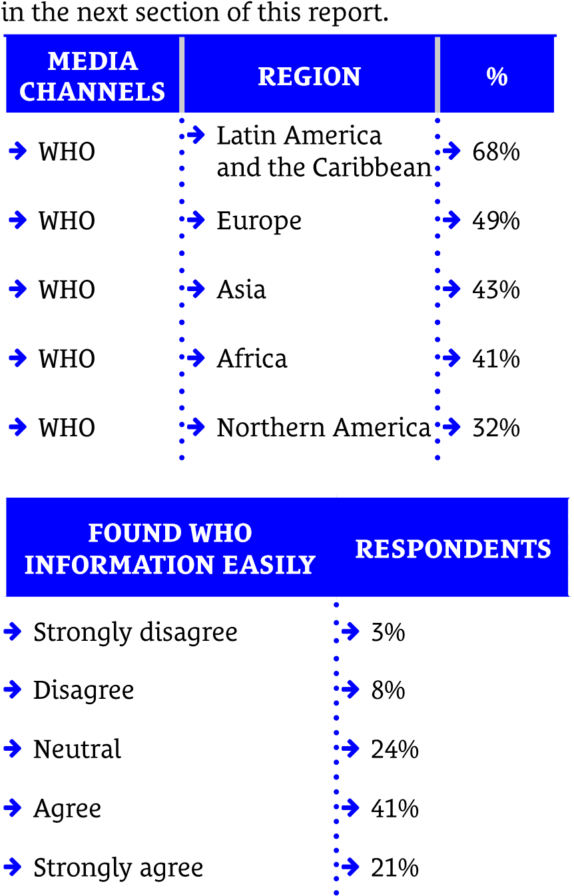

At a regional level, youth expressed mixed feelings concerning their level of reliance on their National Health authorities’ (NHA) websites as a media channel for guidance pertaining to COVID-19. Generally, the reliance was moderate to low across all regions, with youth in LATAM (54%) expressing that they used the NHA website as a preferred media channel more than youths in North America (26%) and Africa (30%). On the contrary, the level of trust in the NHA as a source of guidance pertaining to COVID-19 was relatively high across all regions

(Europe 74%, Asia 68%, LATAM 64%, North America 63% and Africa 56%). It is interesting to note that whilst youth across the different regions expressed a high level of trust in guidance from their NHA, they did not refer to their NHA as a preferred media channel. This could be due to the several media channels available to not only youth, but to the wider general public as well.

Overall, 79% of youth globally felt better prepared now in terms of knowing where to access trusted guidance on COVID-19 compared to the start of the pandemic. In addition, a large proportion of youth (82%) indicated knowing how to critically assess the trustworthiness of information pertaining to COVID-19. To the question “I know how to critically assess which information I receive can be trusted or not” with a likert scale of 1 being Strongly Disagree to 5 being Strongly Agree, the responses were overall positive, as seen in the bar graph below.

Finally, the majority of youth respondents (85%) said they always checked if information they received was verified to a satisfactory level before sharing it online. This was a particularly important metric as the core purpose of this research was to address the spread of misinformation.

**CRITICAL ASSESSMENT**

**%**

h

Strongly Disagree

h

1

%

h

Disagree

h

3

%

h

Neutral

h

13

%

h

Agree

h

37

%

h

Strongly Agree

h

45

%

Whilst noting the above, the survey recorded tiredness (51%) and anxiety (42%) among youth towards COVID-19 related information and news as opposed to interest (15%) and optimism (11%). These results can be explained by the presence of an excessive and constant amount of information on the pandemic.

ATTITUDES OF YOUNG STUDENTS TOWARDS

Tired 51 %

Anxious 42 %

Confused 26 %

Although youth have not been highly affected from a physical health perspective due to COVID-19, majority have been negatively affected from a mental health perspective. Furthermore, youth feel that COVID-19 has negatively affected their future in terms of education, employment and mental health.

Most deaths and infected cases from COVID-19 belong to the oldest cohort of the general population, which runs the highest risk to be infected by COVID-19 (Kluge, 2020). The results of this survey confirm that for the majority of youth (47%), COVID-19 has not had a major impact on their physical health. In fact, 18% of respondents stated that the pandemic positively or strongly positively impacted their physical health whilst the remaining 35% stated that the pandemic negatively or strongly negatively impacted their physical health.

However, to the question “Are you worried about getting infected by COVID-19?”, 55% of the respondents agreed or strongly agreed whilst only 23% disagreed or strongly disagreed. This indicates that whilst most youth have not yet been affected from a physical health perspective, most are worried that COVID-19 could infect them in the futures

Furthermore, the COVID-19 pandemic has had a significant impact on youth mental health. Survey results show that around 58% of youth felt that COVID-19 negatively or strongly negatively impacted their mental health. Studies demonstrate that anxiety,

Negatively affected 43 %

Not affected 25 %

Positively affected 12 %

Strongly positively affected 5 %

BIGGEST CONCERN %

Disruption of everyday life 60 %

Mental health 55 %

Loss of job and financial 44 %

Security Even if the complete disappearance of COVID-19 is still a matter of debate, what is certain is that this pandemic will have long-lasting effects and will shape the future of the world. Accordingly, the survey presented in the report captures youths’ perception on how COVID-19 will impact their future.

Results show that, overall, 53% of youth feel that COVID-19 will negatively or strongly negatively impact their future. In particular, youth mainly fear how this pandemic will negatively or strongly negatively affect their education opportunities (57%), mental health and wellbeing (56%) and financial stability (51%) in the future. Interestingly, youth opinions on the impact of COVID-19 on their future job prospects are divided. 38% of youth believe that the pandemic will not affect this, whilst 47% of them think it will be negatively or strongly negatively affected by COVID-19.

This relatively close balance of results might be explained by the sub-age ranges within the youth respondents, who might not necessarily be concerned with job hunting in their near future. On the other hand, youth who will soon finish their education may be greatly concerned about their future career.

4. Discussion

The findings from this survey differs varyingly based on region, gender, age and socio-economic conditions. This section will dive briefly into these different demographics.

**HOW HAVE YOUTH FROM DIFFERENT REGIONS ANSWERED THE SURVEY?**

As mentioned in the earlier section (Findings), the respondents were grouped into different regions and their responses were analysed to understand if there were similarities or differences among the regions. Due to the low number of responses from Oceania, it was not considered for this particular section.

REGION INFORMATION CHECK %

Asia Strongly Disagree 2%

Asia Disagree 2%

Asia Neutral 12%

Asia Agree 26%

Asia Strongly Agree 57%

Europe Strongly Disagree 1%

Europe Disagree 2%

Europe Neutral 10%

Europe Agree 34%

Europe Strongly Agree 53%

Africa Strongly Disagree 1%

Africa Disagree 4%

REGION INFORMATION CHECK %

Africa Neutral 12%

Africa Agree 24%

Africa Strongly Agree 58%

Latin America

and

the Caribbean Strongly Disagree 1%

Latin America

and

the Caribbean Disagree 1%

Latin America

and

the Caribbean Neutral 10%

Latin America

and

the Caribbean Agree 25%

Latin America

and

the Caribbean Strongly Agree 63%

Northern America Strongly Disagree 1%

Northern America Disagree 4%

Northern America Neutral 13%

Northern America Agree 35%

REGION INFORMATION CHECK %

Northern America Strongly Agree 47%

Asia Strongly Disagree 5%

Asia Disagree 9%

Asia Neutral 25%

Asia Agree 30%

Asia Strongly Agree 30%

Europe Strongly Disagree 10%

Europe Disagree 19%

Europe Neutral 30%

Europe Agree 25%

Europe Strongly Agree 16%

Africa Strongly Disagree 7%

Africa Disagree 8%

Africa Neutral 24%

Africa Agree 24%

Africa Strongly Agree 37%

Latin America and

The Caribbean Strongly Disagree 29%

Latin America and

The Caribbean Disagree 9%

Latin America and

the Caribbean Neutral 18%

REGION INFORMATION CHECK %

Latin America and

the Caribbean Agree 15%

Latin America and

the Caribbean Strongly Agree 28%

Northern America Strongly Disagree 4%

Northern America Disagree 13%

Northern America Neutral 19%

Northern America Agree 32%

Northern America Strongly Agree 32%

We can see that youth across the regions exercise positive behavior with respect to sharing and assessing the trustworthiness of COVID-19 information as the majority of respondents strongly agreed or agreed that they check if information is verified to a satisfactory level before sharing it online and know how to critically assess which information can be trusted. In addition,the majority of youth know where to access trusted guidance on COVID-19 information now as compared to the beginning of the pandemic. When asked if they are worried about getting infected by COVID-19, the responses varied quite extensively among the regions. Whilst 13 Back to ToC  the majority of youth from Asia, Africa and North America strongly agreed that they were worried about being infected (30% or over), the highest percentage for youth from Europe was “neutral” (30%). Interestingly, a similar percentage of youth from Latin America and the Caribbean strongly agreed (28%) and strongly disagreed (29%) that they were worried about being infected by COVID-19.

REGION FOUND WHO HELPFUL %

Asia Strongly disagree 4%

Asia Disagree 5%

Asia Neutral 25%

Asia Agree 42%

Asia Strongly agree 20%

Asia N/A 4%

Europe Strongly disagree 3%

Europe Disagree 8%

Europe Neutral 25%

Europe Agree 43%

Europe Strongly agree 19%

Europe N/A 2%

Africa Strongly disagree 4%

Africa Disagree 6%

Africa Neutral 21%

Africa Agree 40%

Africa Strongly agree 26%

Africa N/A 3%

Latin America and

The Caribbean Strongly disagree 6%

Latin America and

REGION FOUND WHO HELPFUL %

The Caribbean Disagree 6%

Latin America and

The Caribbean Neutral 15%

Latin America and

The Caribbean Agree 43%

Latin America and

The Caribbean Strongly agree 29%

Latin America and

the Caribbean N/A 1%

Northern America Strongly disagree 0%

Northern America Disagree 4%

Northern America Neutral 27%

Northern America Agree 53%

Northern America Strongly agree 13%

Northern America N/A 3%

When comparing whether WHO or NHA content pertaining to COVID-19 was helpful for youth across the regions, we can see similar responses for youth from Asia and Europe where the majority of respondents within these regions agreed that both WHO and their NHA were helpful. However, the majority of respondents from Africa, Latin America and the Caribbean and Northern America appear to have found WHO more helpful than their NHA, where 65% in North America in particular agreed 14 Back to ToC  or strongly agreed that WHO content was helpful as opposed to only 45% agreeing or strongly agreeing that their NHA content was helpful. The above finding is similar when asked whether it was easy to find WHO and NHA content where respondents from Asia and Europer were relatively similar. However, there were significant differences in responses from Africa, Latin America and the Caribbean and North America where each of these regions appear to have found WHO content more easy to find as opposed to their NHA.

REGION OVERALL FUTURE %

Asia Strongly negatively affected 11%

Asia Negatively affected 43%

Asia Not affected 30%

Asia Positively affected 11%

Asia Strongly positively affected 6%

Asia N/A 0%

Europe Strongly negatively affected 5%

Europe Negatively affected 42%

Europe Not affected 43%

REGION OVERALL FUTURE %

Europe Positively affected 7%

Europe Strongly positively affected 2%

Europe N/A 0%

Africa Strongly negatively affected 15%

Africa Negatively affected 39%

Africa Not affected 30%

Africa Positively affected 10%

Africa Strongly positively affected 7%

Latin America and

The Caribbean Strongly negatively affected 11%

Latin America and

The Caribbean Negatively affected 46%

Latin America and

The Caribbean Not affected 26%

Latin America and

The Caribbean Positively affected 11%

Latin America and

The Caribbean Strongly positively affected 5%

Northern America Strongly negatively affected 7%

Northern America Negatively affected 46%

Northern America Not affected 38%

Northern America Positively affected 7%

Northern America Strongly positively affected 1%

As noted from the above graph, we can see that whilst the majority of respondents from Europe feel that their overall future has not been affected by COVID-19, the majority of respondents from every other region feel that their overall future has been negatively affected due to COVID-19. This could due to the socio-economic structures that have been set up within Europe that offer youth more stability in terms of financial and educational opportunities.

**HOW HAVE THE DIFFERENT GENDERS AMONG YOUTH ANSWERED THE SURVEY?**

GENDER MEDIA CHANNELS %

Female Facebook 21%

Female Instagram 24%

Female National Health Authority 36%

Female Newspapers / Electronic Journals 50%

Female Television News 43%

Female Twitter 20%

GENDER MEDIA CHANNELS %

Female Whatsapp 11%

Female WHO 51%

Female Youtube 11%

Female Others 29%

GENDER MEDIA CHANNELS %

Male Facebook 28%

Male Instagram 21%

Male National Health Authority 38%

Male Newspapers / Electronic Journals 45%

Male Television News 41%

Male Twitter 20%

Male Whatsapp 13%

Male WHO 45%

Male Youtube 19%

Male Others 32%

Other Facebook 43%

Other Instagram 29%

Other National Health Authority 43%

Other Newspapers / Electronic Journals 71%

Other Radio 14%

Other Television News 29%

Other Twitter 57%

GENDER MEDIA CHANNELS %

Other WHO 43%

Other Youtube 14%

Prefer not to say Facebook 26%

Prefer not to say National Health Authority 32%

GENDER MEDIA CHANNELS %

Prefer not to say Newspapers / Electronic Journal 37%

Prefer not to say Radio 16%

Prefer not to say Television News 63%

Prefer not to say Tik Tok 11%

Prefer not to say Whatsapp 21%

Prefer not to say WHO 53%

Prefer not to say Youtube 37%

Prefer not to say Others 42%

COVID-19 has sometimes been labelled as “in-discriminatory” for the global nature of the pandemic which has affected all countries in the world. Yet, studies have demonstrated that the virus affects men and women differently. Most of this research focuses on how the virus impacts differently physically depending on gender, with death rate by COVID-19 being increasingly higher for men than for women. This report departs from the majority of the existing literature as it aims at explaining how information and attitudes towards COVID-19 vary based on gender. Generally, results show that females usually consult more sources of information and have more feelings towards the pandemic than men. As far as information on COVID-19 is concerned, both men and women consult and trust WHO. 51% of women and 45% of men rely on the WHO website and publications to keep themselves updated – with 79% of women and 74% of men considering WHO as the most reliable source. In both genders, less people rely on social media and National Health Authorities for information – 21% of women and 28% of men use Facebook and 36% women and 39% men consult National Health Authorities to inform themselves. Interestingly, men use WhatsApp and YouTube as a source of information – 13% and 19% respectively – while only 11% of women seem to rely on both WhatsApp and Youtube. Chat-based platforms such as WhatsApp have, indeed, created “Coronavirus information hubs”5 (WhatApp, 2020) to connect people from around the globe.

Given the numerous sources of information and the different news and data, both men and women feel mainly anxious and tired when reacting to COVID-19 news. Since January 2020 news have daily been showcasing information, updates and breaking news on COVID-19; at the same time news consumption skyrocketed. This pattern has led many to fatigue and anxiety: “It is so easy to get lost on the Internet with one article leading to another […] Mentally, it [so much news] can be quite overwhelming” 6 (Savage, 2020).

HOW HAVE YOUTH VS NON-YOUTH ANSWERED THE SURVEY?

When comparing the aggregated results from youth ( 21 and below) across all regions (2,666 respondents) versus the results from non-youth (above 30) across all regions (456 respondents), the responses are quite similar to a number of questions such as impact of physical health due to COVID-19 and worry of being infected by COVID-19. However, non-youth edged slightly higher on being better prepared now in terms of knowing where to access trusted COVID-19 guidance compared to the start of the pandemic (81%) compared to youth (79%). More interestingly, non-youth (61%) feel even more strongly than youth (53%) that their overall future has been negatively affected by COVID-19. This further applies to future relationships with friends and family (36% for non-youth vs 32% for youth), future job prospects (51% for non-youth vs 47% for youth) and future financial stability (58% for non-youth vs 51% for youth). Considering that non-youth are in most circumstances breadwinners for their family, it is understandable that this demographic would consider the latter two to be more serious concerns as opposed to youth who could currently be undertaking their education. This is further reinforced from the survey where 57% of youth feel that COVID-19 has affected their future education opportunities as opposed to 41% of non-youth. The media channels used by the two age demographics for information pertaining to COVID-19 varied quite extensively as well. Whilst most youth relied on WHO and Newspapers/ electronic journals (48% each) as their media channel, most non-youth relied on television news (50%) and Facebook (40%) respectively as seen in the below graph. An interesting point to note is how youth have referred less to popular social media channels such as Facebook (24%) for COVID-19 information and guidance as opposed to non-youth (40%).

AGE GROUP MEDIA CHANNELS %

21 & below Facebook 24%

21 & below Instagram 22%

21 & below National Health Authority 37%

21 & below Newspapers / Electronic Journals 48%

21 & below Television News 42%

21 & below Twitter 20%

21 & below Whatsapp 12%

21 & below WHO 48%

21 & below Youtube 14%

21 & below Others 30%

Above 21 Facebook 40%

Above 21 National Health Authority 27%

Above 21 Newspapers / Electronic Journals 32%

Above 21 Radio 12%

AGE GROUP MEDIA CHANNELS %

Above 21 Television News 50%

Above 21 Twitter 15%

Above 21 Whatsapp 24%

Above 21 WHO 26%

Above 21 Youtube 12%

Above 21 Others 26%

There was a significant difference in the responses to current and future mental health between the two age demographics. Whilst 58% of youth felt that their mental health has been negatively and 56% of youth felt that their future mental health will be affected due to COVID-19, non-youth answered 42% and 47% respectively. As indicated several times in this report, mental health is one of the main concerns among youth which can be caused by uncertainty of the present and future. Mental health support groups in Victoria, Australia noted a 20% jump in pleas for help since severe lockdown restrictions began due to factors such as job loss and youth unemployment and this may be similar around the world as well.

AGE MENTAL HEALTH %

21 & below Strongly negatively affected 15%

Above 21 Strongly negatively affected 9%

21 & below Negatively affected 43%

Above 21 Negatively affected 33%

21 & below Not affected 25%

Above 21 Not affected 37%

21 & below Positively affected 12%

Above 21 Positively affected 17%

21 & below Strongly positively affected 5%

Above 21 Strongly positively affected 4%

QUALITATIVE SUGGESTIONS TO WHO:

The survey received 1,183 qualitative suggestions to WHO on how they may improve the guidance that they have published on COVID-19. They have been summarized into bullet points and are as follows:

1. Fact-checking and fighting misinformation came as a concern for youth asking WHO to share more facts, point out and bust false info and enforce regulations to prevent and stop it especially those coming from governments and leaders while reaching out to nonbelievers and engaging with them.

2. Locally-tailored actions and approaches came repeatedly focusing on adapted guidelines and recommendations to the specific country and cultural, religious and social contexts, use of local languages in communication, collaboration and engagement of local and national authorities and decision-makers, while focusing on countries facing challenges, LMICs and those in low-resource settings.

3. Emphasis also came on awareness and education of people focusing on those not reachable by technology tools such as in rural areas, the elderly, and poor ones. Other stakeholders include health workers, media, decision-makers and influencers.

4. Suggestions about increasing accessibility and availability of WHO content by using more platforms and collaborations and focusing on underprivileged target groups.

5. Youth asked for more clear, simpler and easier to understand and to disseminate content from WHO, focusing on short non-technical messages, userfriendly methods aimed for the general public.

6. Youth asked for constant updates and information sharing from WHO, providing more prompt and concise content online in a quick way

7. Recommendations about optimizing social media use with more simple, creative and appealing content, use of more platforms, ads, collaboration with influencers and other methods

8. Better promotion, marketing and advertisement for WHO and its content was suggested to increase its credibility, trustworthiness and outreach.

9. Suggestions about increasing the “honesty and transparency” of messaging by WHO and to ensure that guidance is backed up with data and references.

10. More meaningful engagement of youth was reclaimed including different recommendations such as engaging youth ambassadors and volunteers, capacity building, youth-tailored campaigns, programs and content, and offering spaces for sharing, networking, and stating their voices.

11. Some Criticism was also observed, considering WHO as confused, pessimistic, political or biased, changing their stance and recommendations(repeated many times), hiding or sharing wrong information, scaring people and also asking WHO to stop being inclined to China.

12. Others praised and thanked WHO and appreciated their work especially the constant updates and recommendations being shared while wishing them luck dealing with misleading country leaders.

13. Suggestions regarding preferred ways for communication to be used included catchy, easily translatable and understandable super-short videos, infographics, news channels, apps with push function free online learning course, chatbot, podcasts, emails, personal stories and other visual tools.

14. Youth asked about updates on different topics mainly COVID basic information and explanations, updated symptoms list, prevention and protection methods and guidelines, vaccine updates, conventional and home treatments, its impact on health and other SDGs, positive news, frequently answered questions (FAQs), good practices and information and tools for mental health support and care.

RECOMMENDATIONS:

Based on the results and main findings of the survey, we as representatives of youth worldwide would like to call upon decision-makers, international organizations, UN agencies, NGOs, and other relevant stakeholders to: h Encourage the creation and prolonged operations of youth engagement platforms across international organizations, national and local governments as specified in the United Nations Youth Strategy8 to better understand the needs and wants of youth such that they may raise issues, concerns and solutions towards the COVID-19 pandemic h Provide accessible, confidential, and effective mental health support services for all youth online and at the community level 8 United Nations (2018). United Nations Youth Strategy. https://www.un.org/youthenvoy/youth-un/ h Implement programs for awareness and empowerment of youth on risk communication to enable them to act actively within their communities while building their resilience h Create spaces for capacity building and new skills development for youth and adapt job offers and conditions to the new situation to improve their financial stability h Engage resources to ensure continuity of education for youth especially for those in low resource settings h Engage media actors especially newspapers, electronic journals and social media, TV, and radio by building their capacity and implicating them in risk communication, fact-checking and strategic information spread using engaging and adapted communication methods and content h We call upon youth around the world to: h Create a support system for each other and for their close ones to ensure a positive environment and reduce stress, anxiety, and mental issues levels. h Engage in their communities against COVID and misinformation by promoting good practices for correct information consumption. h Catch up with disruptions in education by enrolling in alternative educational resources and tools h Use peer education and training as a way to ensure mutual empowerment and preparedness for educational and working spaces

Final Considerations

This report has highlighted the results of an online survey focused on youths and COVID-19. By analyzing the responses of 2,666 youths from all around the world, some of the most pressing issues governments and international organizations should consider when formulating a response to COVID-19 pandemic have been highlighted. Youth’s mental health, education and employment are only some of the crucial topics authorities should keep in mind to formulate an holistic response to the pandemic which does not leave the youngest generation behind. This report aims to be a baseline against which future research can expand and develop. Accordingly, it is important to underline that, even if many themes were tackled in the analysis of the survey’s respondents, the results presented do not represent an ending point, but rather a starting one. Some of the issues are relevant to the wider theme of ‘Youth and COVID-19’ but were not able address specific issues such as how the pandemic has affected youth in minority groups through, for example, language and discrimination. To elaborate further: h Language: the misinformation of certain groups or parts of the population because of language barriers is a crucial fact to keep in mind. Even if able to critically process and analyze information, youth belonging to linguistic minorities might be left behind and easily misinformed. Indeed, “It has to be noted that countries have not systematically shared the information, instructions, guidelines or recommendations in languages other than the official language of the country […] The communication of relevant recommendations in these languages is of utmost importance for the well-being of the speakers of regional or minority languages.”9(Council of Europe, 2020) h Discrimination: racial discrimination and how it changed during the pandemic is another factor which might be interesting to survey among youths. Data, indeed, show that beyond causing an unprecedent health crisis, COVID-19 has also increased discrimination – especially towards immigrants with Asian origins and/or traits. All in all, this report wishes to call international organizations and governmental authorities to include youth voices in their response to the pandemic, taking into consideration the issue explored in this report and beyond. We are all in this together and let us youth be a part of the solution, not just a part of the problem

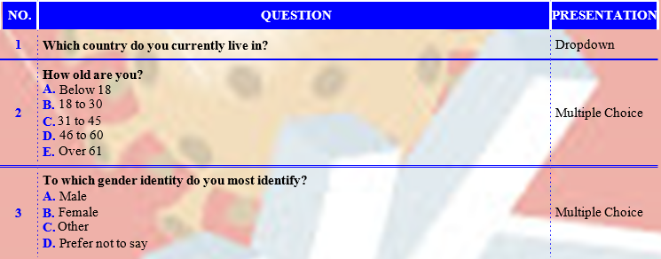**SECTION 1**

**SECTION 2: YOUTH AND INFORMATION NETWORKS**

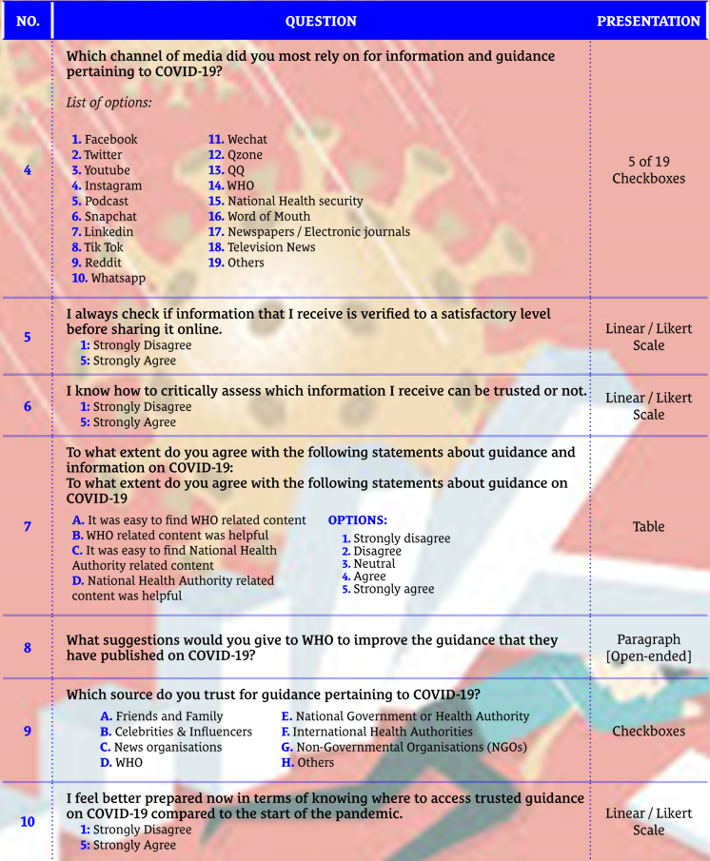In this section, we wish to focus on assessing our attitudes towards guidance and information pertaining to COVID-19. **Information** refers to COVID-19 related content such as, but not limited to, updates on newly found treatments, vaccines etc.

**SECTION 3: YOUTH ATTITUDES TOWARDS COVID-19**

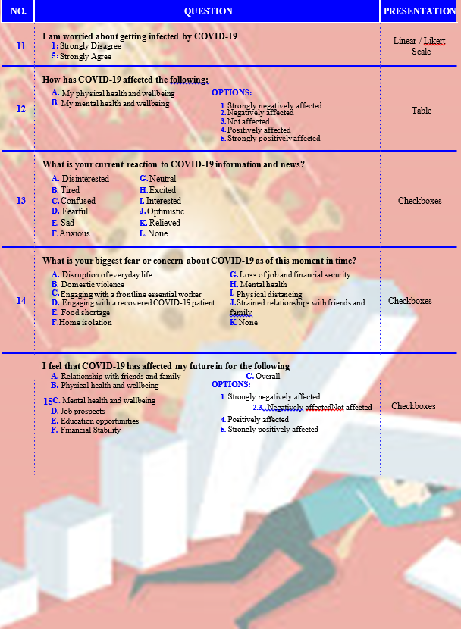 **This section aims to evaluate our current attitudes and reactions pertaining to COVID-19.**

1.
2.
3.
4.